World Literature Classes Overview
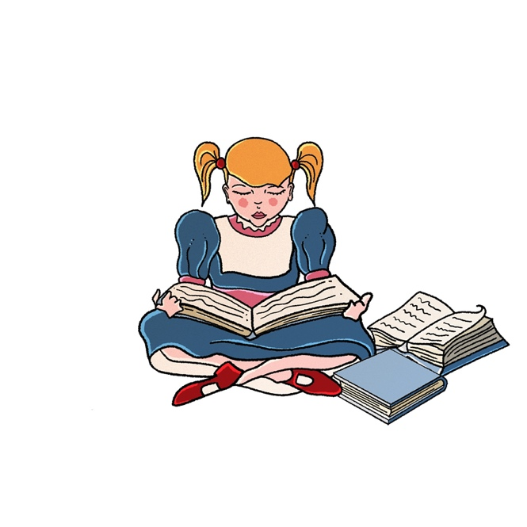
Minds Underground

Minds Underground’s World Literature Club classes cover a wide period of time and encompass the many different definitions and critical ideas concerning World Literature. The Club offers an opportunity for students to broaden their horizons in Literature, to consider authors and literary theorists from across the globe. The Club classes are hosted by members of our Oxbridge-educated team, from a Fellow at all Soul’s College, University of Oxford, to published authors and Master’s and PhD researchers specialising in postcolonialism and global literature.
Why join the World Literature Club?
The World Literature functions somewhat like a book club for high-performing, intellectually inquisitive students, looking to stretch beyond the curriculum and develop analytical & critical discussion skills. Sessions are used as a launch pad for students to pursue their own interests.

Skills Gained:
- Widened reading repertoire
- Ability to engage in literary analysis & criticism
- Building possible content for personal statements for those applying for Humanities degrees
- Heightened cultural understanding: The World Lit Club delves into authors & themes from across the globe, spotlighting forgotten voices and literary talent from a diverse range of cultures & histories
- Communication & presentational skills: The classes are highly interactive, offering students an opportunity to voice their ideas in front of the class, in communication with subject experts.
How are classes structured?
Each session will introduce the week’s topic, generating a discussion that mimics the Oxford tutorial system (close critical discussion of texts). Students may be set creative essays, short presentations on books & articles and reading between sessions, though classes also stand alone to ensure a missed week will not set students back. The nature of this course requires in-depth and interesting discussion. There is not a simple approach to World Literature and therefore each session will involve a form of debate – either formal or informal.

What modules/ topics are typically covered?
Some example past topics are listed below – we also encourage Club members to prioritise topics/ books catered to their interests, both within each module and outside of it if other topic areas are of interest. For example, students can pursue their own favourite myth or choose a film adaptation of a novel that they have enjoyed to analyse. They should never feel confined in their reading.
Alongside the modules listed, mentors often allow students to pick from our World Literature masterclasses on our online platform, Minds Underground™.
Example Modules
Introduction to World Literature – What Is World Literature?
  - Students delve into the different critical ideas surrounding World Literature.
  - This ranges from looking at the coinage and original definition of the term by Goethe in his 19th century Weltliteratur, to ideas introduced in Marx’s Communist Manifesto and Carlos Fuentes’ idea of multiculturalism, that ‘reading, writing, teaching, learning, are all activities aimed at introducing civilizations to each other’.
  - Is world literature ‘the autobiography of civilization’? What sort of problems come with viewing the history and structure of world literature as a single, coherent story told by a single subject?
  - Students may examine the writings of Christopher Prendergast, Debating World Literature (2004) and David Damrosch, Teaching World Literature (2009) who take a more diverse and pluralised view of world literature and relate this study to our understanding of human cultures.
  - They may also look at Moretti and his idea that world literature far exceeds what cannot be easily understood through close reading, but instead ‘distant reading’ that looks at large-scale patterns as discerned from publication records and national literary histories, enabling one to trace the global sweep of forms such as the novel or film.
Otherworldly Literature – Literature of the Ancient Worlds
  - This module turns to works that seem to bridge the barriers between worlds. World Literature has a heritage; it does not only relate to the present – it must have started somewhere. How and why are the stories of the Ancients still relevant to our world today?
  - Students explore Epic Poetry – Homer’s The Odyssey and The Iliad, Virgil’s Aeneid. Why were these works written? Why have these works lasted? What ideas do they contain that ensures they remain vital and popular? How have they been adapted over time?
  - How are these works transmitted? – an exploration of the idea of orality and how it is helpful in creating a World Literature.
  - The plays of Sophocles – Antigone and Oedipus Rex. The birth of playwrighting – why are these works still being performed today? Do their ideas feel outdated or modern?
  - The myths of Hesiod – the tales of the Greek and Roman Gods. Is there such a thing as a modern myth?
  - Are Latin and Greek really ‘dead languages’ or does their legacy make them very much alive? Are they arguably the most universal languages?
  - Do modern franchises such as Percy Jackson and Robert Harris’ Imperium series cheapen the significance of ancient writings or bring them to life?
Fairy Tales
  - Arguably the most universal and recognised writing form – what elements of the fairy tale make it so universally popular? e.g. magic, moral, good and evil, monsters, royalty.
  - Fairy tale/Folk tale – it is implied in the name that these are the stories of a universal people.
  - Do they have to be aimed at children or are they for everyone? If they are aimed for children, why are they often so dark? How do they explore the human condition?
  - Brothers Grimm – early German folktales – looking at the earliest version of Cinderella and Sleeping Beauty.
  - Hans Christian Andersen and his tales of the 19th century.
  - How does essentially the same fairy tale differ between different countries and what does this tell us about culture and the way different nationalities read?
  - What is the difference between fairy tale and fantasy – does Harry Potter or Lord of the Rings for example contain elements of the fairy tale?
  - How are fairy tales being adapted today? – looking at Disney and Pixar – block buster movies such as Frozen and Shrek.
  - How fairy tales have inspired other art forms – particularly music and dance: Tchaikovsky’s Sleeping Beauty and Swan Lake, Bartók and Balász’s Bluebeard’s Castle, Dvořák’s mermaid opera Rusalka, or a Ballets Russes production such as The Firebird.
Classics
  - What is a classic? Look at different writers’ definitions. For example, Italo Calvino’s essay Why Read the Classics? (1991)
  - Students encouraged to pick their own favourite classic and then try and determine the uniting elements. What features re-occur in their choices?
  - Who decides on the classic? Is it biased? Looking at the ‘white male canon’.
  - Does a book have to be universal to be a classic or can countries have their own?
  - Should classics be updated or does that defeat the point?
  - Should classics be dismissed for outdated views – e.g. sexism, racism, homophobia or merely read with the idea of context in mind. For example, is it right that Huckleberry Finn is not taught in certain schools due to its racist language?
Translation and Reception
  - What does it do to a book if it is translated? The idea of ‘lost in translation’ or ‘language barriers’
  - Comparing different translations and seeing how that affects one’s reading.
  - Is it important that the nuances of language are maintained? Can they ever be maintained?
  - Looking at attempts to create universal languages – such as Esperanto. (can look at how this interpreted by authors such as Orwell’s 1984’s Newspeak.)
  - Looking at universal works such as Tolstoy’s War and Peace, Love in the Time of Cholera by Gabriel García Márquez…the list is endless, students very much encouraged to pick their own.
  - Looking at authors who write in multiple languages e.g. Nabokov’s Lolita. Seeing how this book is received when translated to different cultures – for example it is still banned in certain countries.
The World Wide Web of Literature
  - What does World Literature look like in the 21st century?
  - How has social media affected the way we read?
  - Look at fanfiction websites like Wattpad. Look at the example of how 50 Shades of Grey, now a worldwide success, was originally a fanfiction posted on the internet.
  - Look at Instagram poets such as Rupi Kaur. Why does she cause such division? Is her work bringing more people to poetry or ruining its status as a high art form?
  - Do authors need to have a social media presence now?
  - How does the job of a screenwriter differ from an author?
  - What role has Hollywood and the film industry played in literature?
  - Does having universally read literature destroy individuality?
  - Do people read differently now because of social media? – i.e. is there a demand for shorter, snappier writing?

